- SM59: Create RFC_Destination:
Target host and Path prefix we get from Iflow after deploying.

Mandatory settings.
Check RFC destination configuration: iflmap* url as host name, 443 as port, set basic authentication, SSL activated, set logon user and pwd 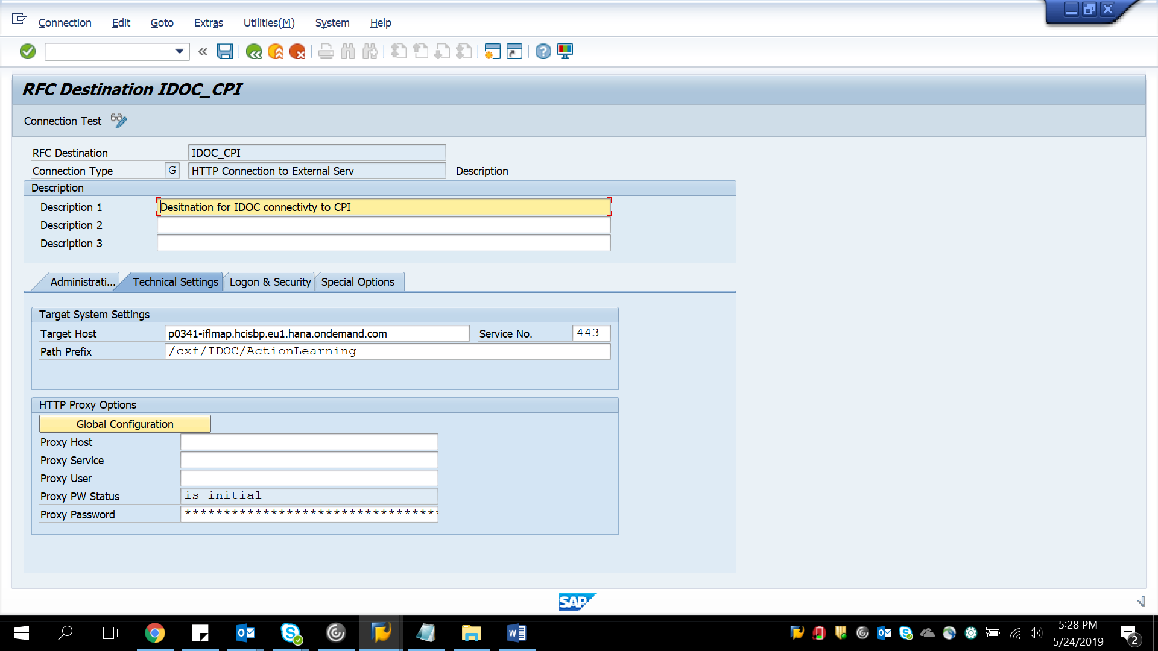

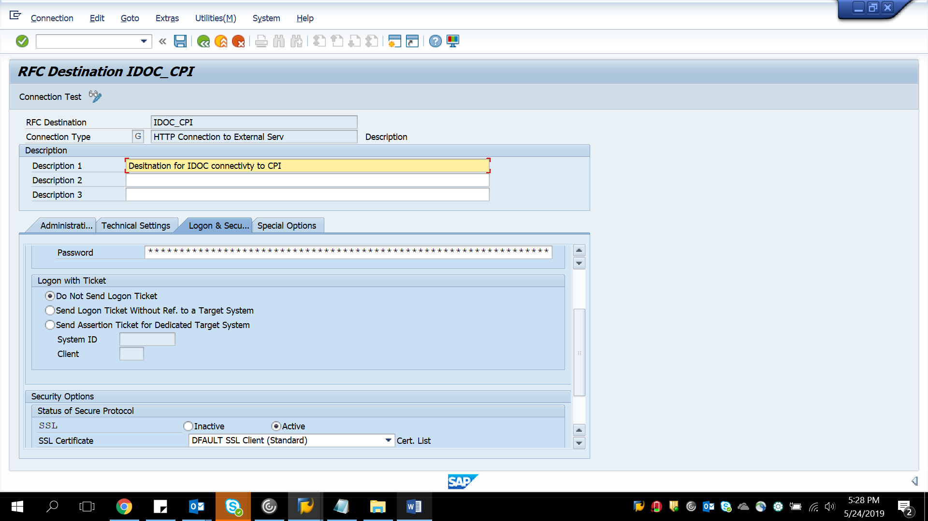

- Create logical system in BD54
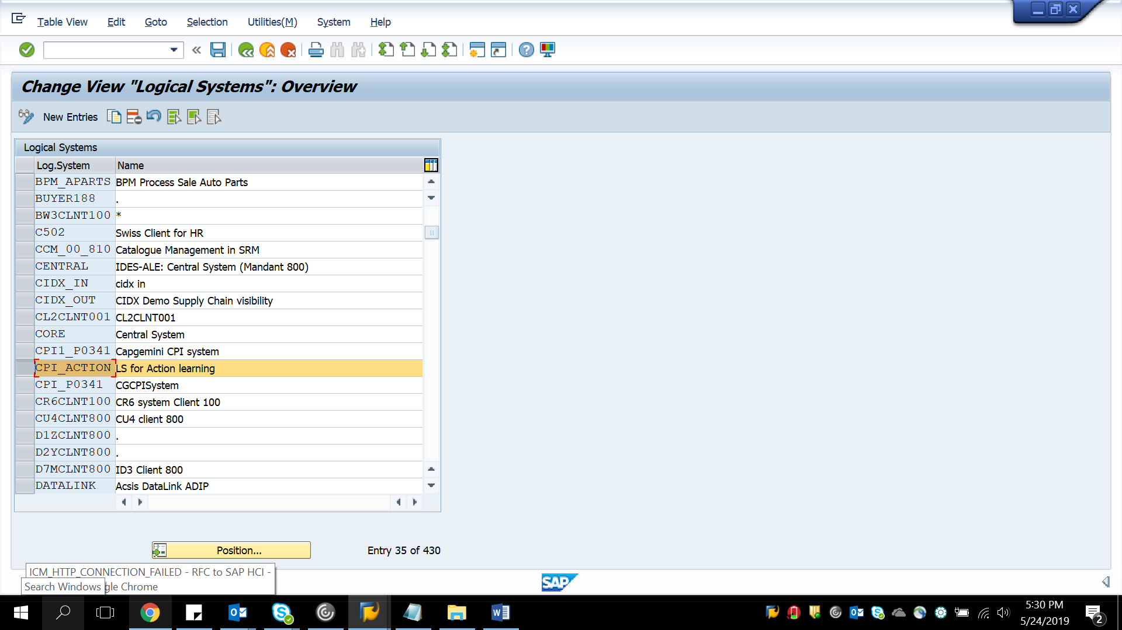

- Create Partner profile

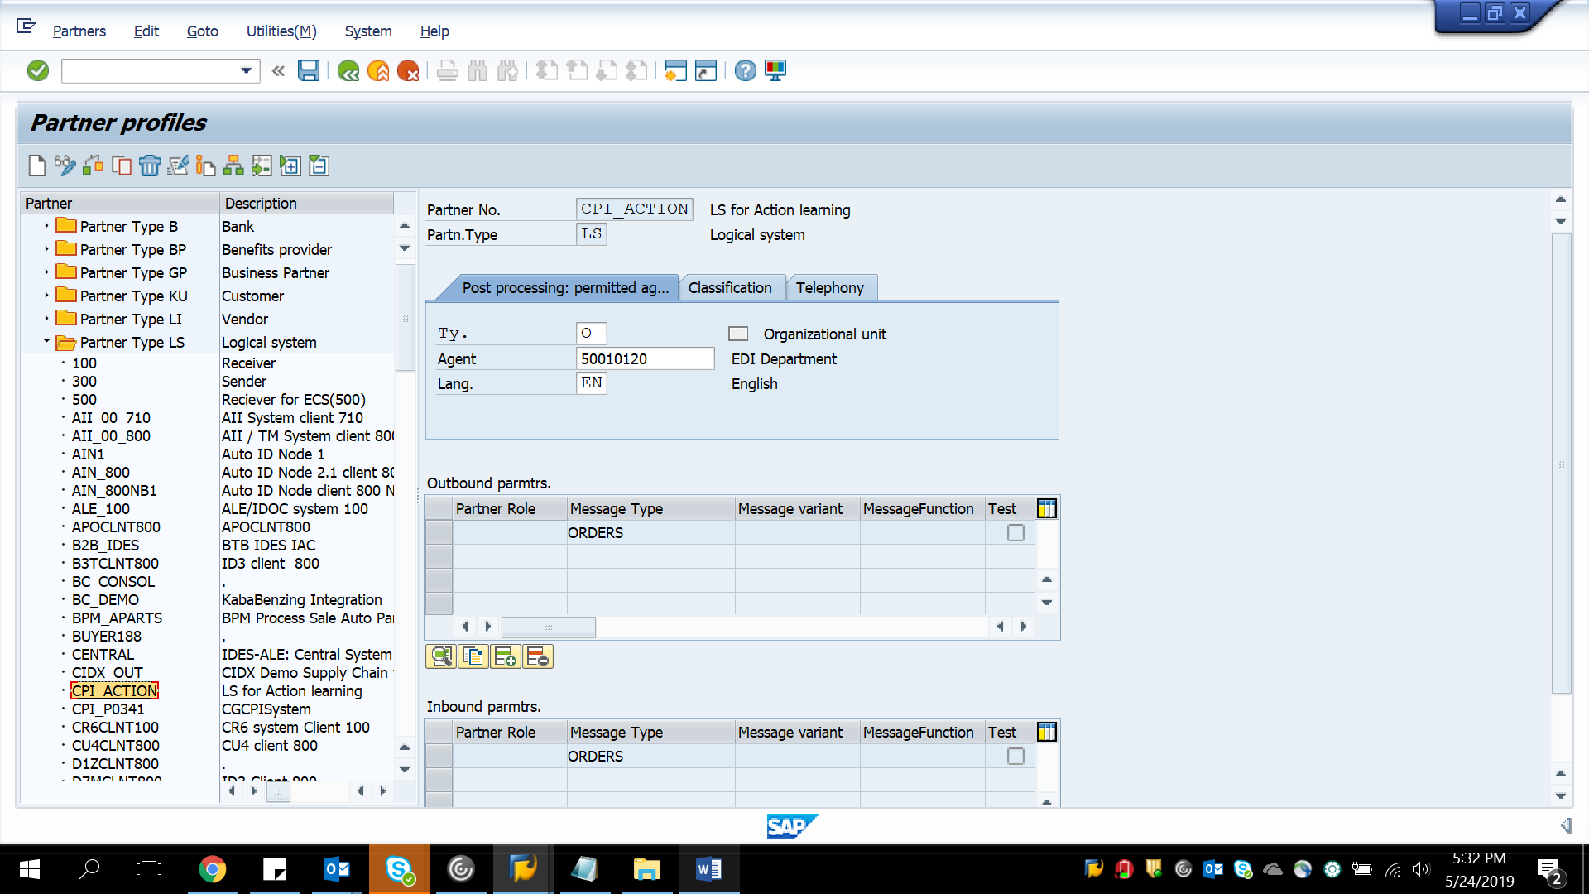

- Create port for RFC_destination
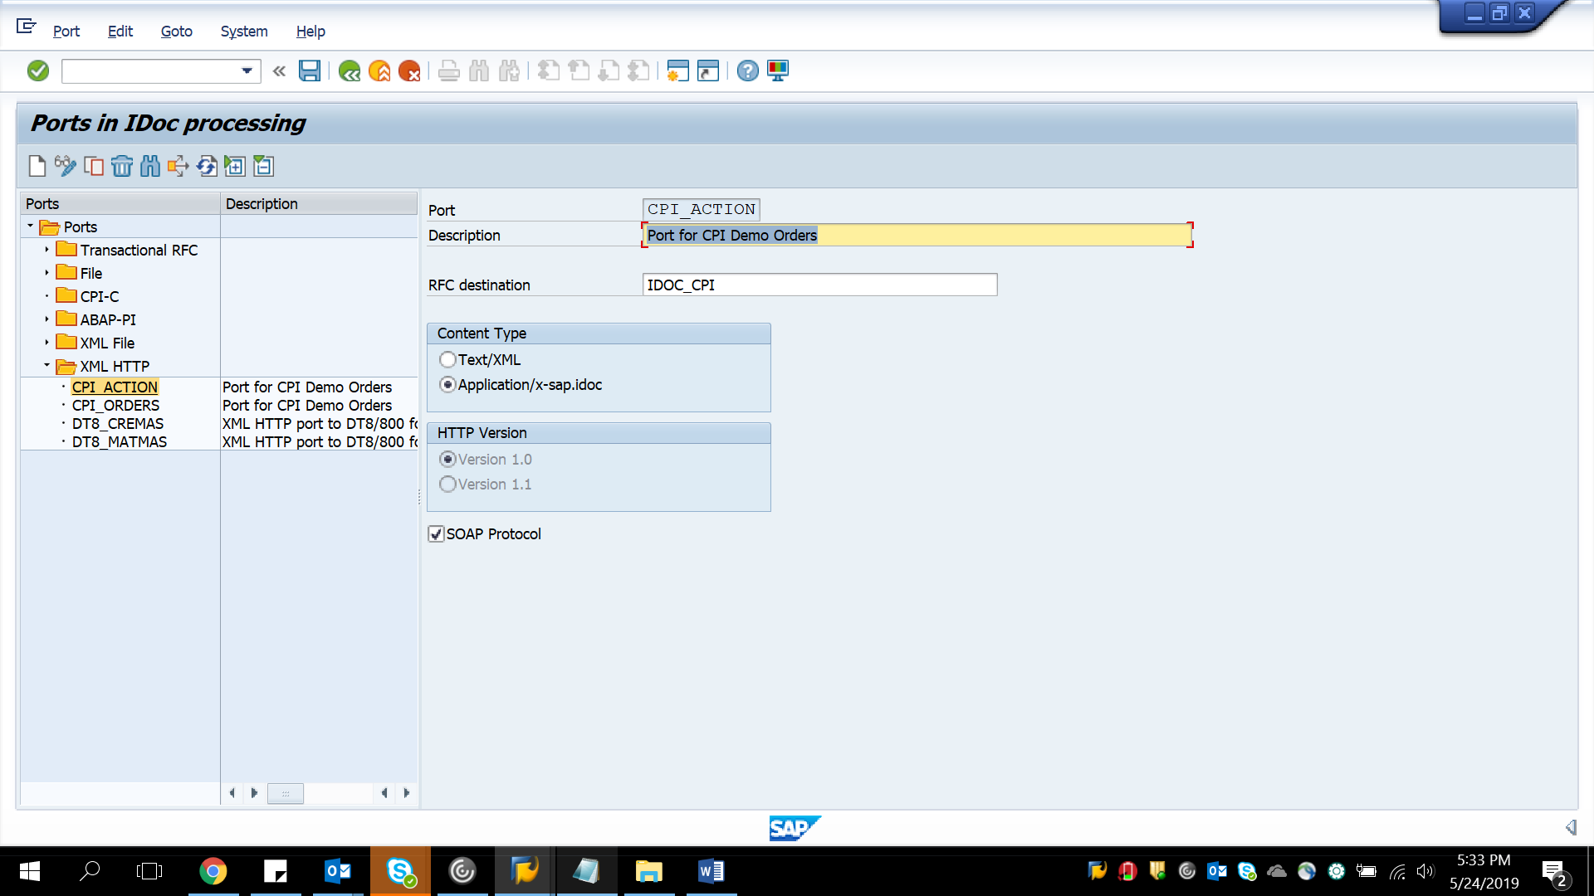

For triggering test data from We19
Select your appropriate PORT, Partner Type, Message type.
